Cell Engineering - Exercise Session 2

Please note that this exercise session is graded, and that each student will have to submit an individual report.

CAR-T cell therapy
In order to achieve full activation and proliferation, native T-cells rely on receiving three essential signals: Signal 1, mediated by T-cell receptors (TCRs); Signal 2, mediated by costimulatory receptors; and Signal 3, mediated by cytokine receptors. Each of these signals operates through distinct intracellular domains, as depicted in the left-hand diagram below.

Chimeric Antigen Receptors (CARs) offer a promising avenue in synthetic biology for enhancing T-cell functionality. CARs can incorporate one or a combination of the previously mentioned intracellular domains, as illustrated in the right-hand diagram below. However, the most effective CAR design incorporates all three types of domains, ensuring full T-cell activation upon recognition of tumor antigens.
.

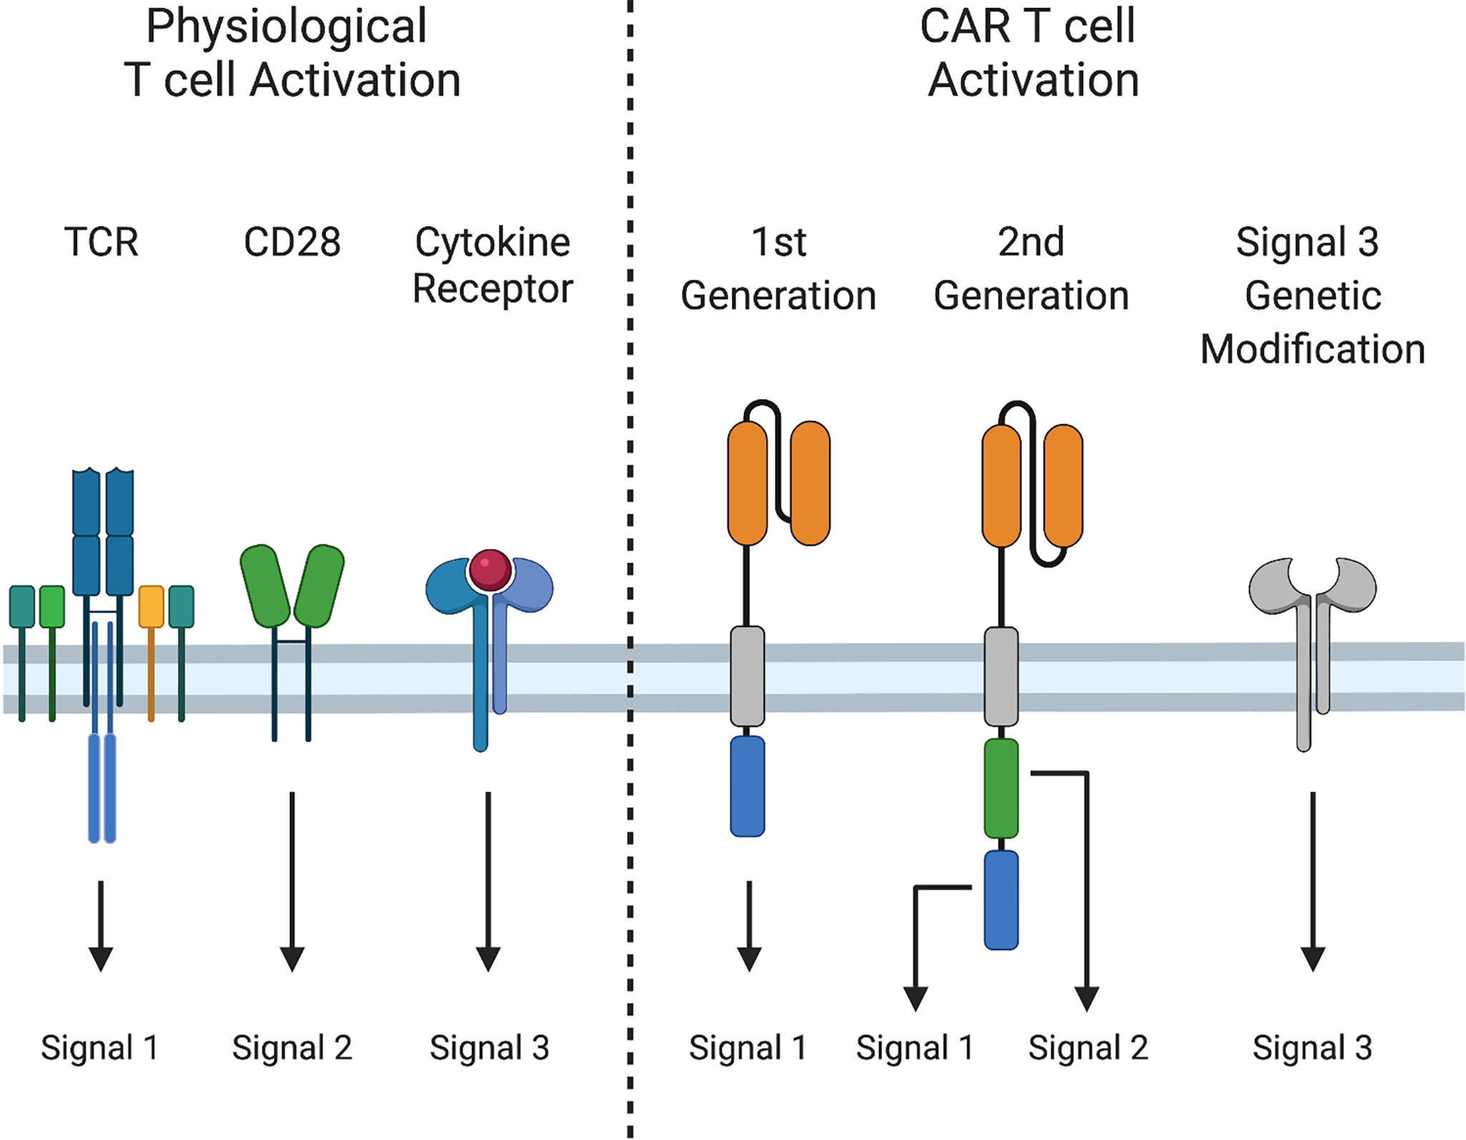
Please note that the figure referenced in this problem set, taken from https://doi.org/10.3389/fimmu.2021.684642, does not depict a Chimeric Antigen Receptor incorporating all three signals. However, it's important to acknowledge that CAR designs incorporating all three signals do exist.

A recent breakthrough has introduced an innovative approach based on AND logic gate mechanisms to regulate CAR T-cell activation. In this method, CAR expression is contingent upon the activation of another receptor (synNotch), offering precise control over T-cell response. The system works as follows (see figure below): (1) Antigen A activates a SynNotch receptor which then drives the expression of a chimeric antigen receptor. (2) Upon binding to antigen B, the CAR then activates the CAR T-cell through signal 1, 2 and 3 (all three signals are required for full and strong activation).

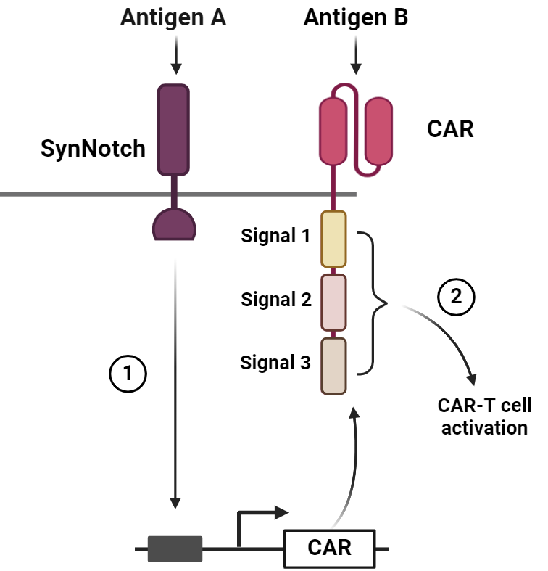

Question 1a)
A notable drawback of the circuit shown above is that the CAR T-cell response is rather slow. Can you think of another strategy to engineer AND logic gates that control T-cell activation with a more rapid and dynamic response?
- clearly mention what the slow step is
- please provide a clearly labeled schematic figure of your improved circuit and explain why it is more rapid than the original one.
- note: Multiple solutions are possible, just ensure that your designed circuit requires AND logic (requiring antigen A AND B) for full activation of the CAR T-cell. Assume that you can introduce constitutively expressed genes in your CAR-T cell, and that you can split and recombine domains as you like.

Question 1b) Do you foresee any potential problems/issues that might arise with your newly proposed strategy?

SOLUTIONS

Question 1a) The slow step in the shown circuit is step 1 - the expression of the CAR driven by activation of the SynNotch receptor. It would be much quicker if the CAR was already expressed, however we need to make some modifications to keep the AND gate logic.

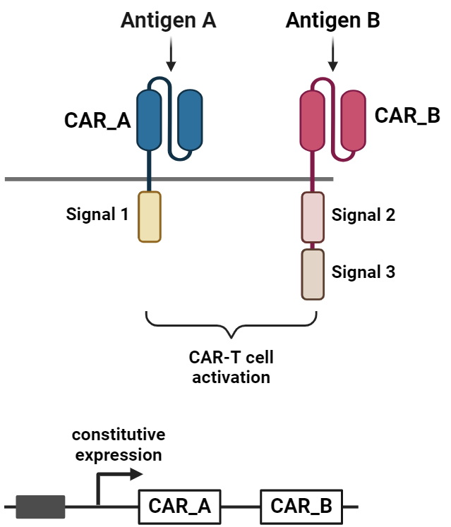
Note that there are other options, the solution here is just one of them
To obtain a system with a more rapid response, we should get rid of the first step (SynNotch driving expression of CAR). To have an AND logic gate, we could split the original CAR into two CARs that are constitutively expressed: one recognizing antigen A and inducing signal 1, the second CAR recognizing antigen B and inducing signal 2 and 3 (other combinations of the three signaling domains are also possible, you could even create three CARs with one signaling domain each).This system will have a faster response, and full CAR-T cell activation will only be achieved in presence of antigen A AND B.

Question 1B) There could already be some partial undesired CAR-T cell activation even if not all of the three signals are present (the AND logic gate is weaker).

